Helplines
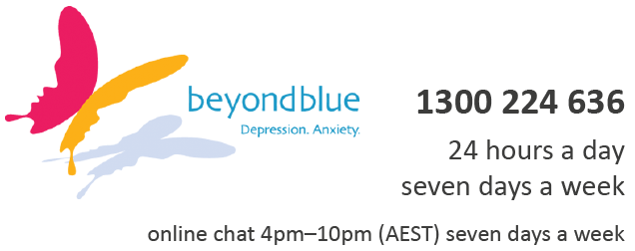 | youthbeyondblue Support Service  Call or chat online with a trained mental health professional.  We'll be there to listen, offer support and point you in the right direction.
13 11 14
For urgent assistance call Lifeline which is a 24-hour telephone counselling service.
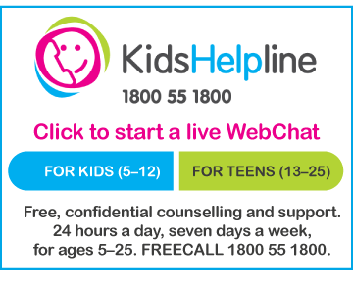 | A free, private and confidential telephone and online counselling service specifically for young people between five and 25.  Free even from mobiles!
A confidential telephone service providing professional counselling and support for parents and carers of children in Queensland and the Northern Territory.

Call Parentline on 1300 30 1300, from 8am to 10pm, seven days a week for the cost of a local call.

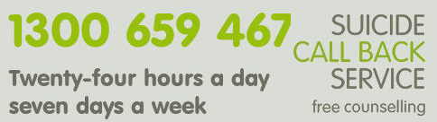  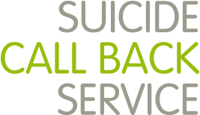 | Suicide Call Back Service provides free phone, video & online counselling for anyone affected by suicide.  Get immediate help now by selecting one of our counselling services.
A leading provider of relationship support services for individuals, families and communities. We aim to support all people in Australia to achieve positive and respectful relationships.
1 300 364 277 Mon-Fri 8am-8pm / Sat 10am-4pm
Support for Australian men anywhere, any time | MensLine Australia is a professional telephone and online support and information service for Australian men 24/7

Bullying and Cyberbullying

Bullying. No Way! (for teens)
Provides information on what to do if you are being bullied, been called a bully or know someone who is being bullied.
Keep it Tame
Shows the risks of taking a 'joke' too far online, and what to do if you are on the receiving end.
eSafety
Information on how to deal with online issues including cyberbullying, trolling, digital reputation and sexting. *** Incredible resource for learning how to protect children online
iParent
Shows you how you protect your digital identity. Parents can learn about the digital environment and keep updated on their children’s technology use; find guidance for using safety settings on your family’s web-connected devices, tips for choosing movies and games and strategies for keeping young people safe online.
Games, Apps and Social Networking Quick guide to popular social media sites and apps: Protect yourself and your children.
Report Cyberbullying Learn more, get advice and strategies or lodge a cyberbullying complaint in response to harmful or serious cyberbullying.
Cyberbullying Complaint Resolution Process
Cyberbullying complaints Form Download DOCX (65.9KB)
THINKUKNOW: YOUTH
Established by the Australian Federal Police ThinkUKnow is a free, evidence-based cyber safety program that provides aaccessible cyber safety education to youth, aged 11-17.

THINKUKNOW: PARENTS, CARERS AND TEACHERS

Established by the Australian Federal Police ThinkUKnow is a free, evidence-based cyber safety program that provides accessible cyber safety education to parents, carers and teachers through schools and organisations across Australia.

Useful websites

headspace
Provides support to young people aged 12 to 25 who are going through a tough time, including anxiety, depression, bullying and body image.
eheadspace
Internet chat, email or phone support for young people (12-25 years) with a range of issues. Call the helpline on 1800 650 890.
REACHOUT.com
An online youth mental health service that helps young people with information, support and stories on everything from finding motivation to getting through tough times.

REACHOUT.com Parents

Reliable information for parents about supporting young people’s mental health and wellbeing

Black Dog Institute

Creating a mentally healthier world: The Black Dog Institute website has been designed to assist anyone seeking help or information about mental health and wellbeing.

Bite Back

Share real and personal stories with others, check out videos, blogs and interviews of interesting people, check and track your mental fitness, and get your teeth stuck in to a bunch of activities.

Supporting family members with a mental health condition

Young Carers
Gives you tips on how to look after yourself and the person you are caring for. You can also call their help line on 1800 242 636

Children of Parents with a Mental Illness (COPMI)
Having a parent with a mental illness can be tough. But COPMI have a lot of information and videos to help you get your head around it all. There's also great information for parents too.

Commonwealth Respite and Carelink Centre

Information to organise services such as home respite care, support workers and residential respite care. You can call them directly on 1800 052 222.

Eating disorders and body image

The Butterfly Foundation
Represents all people affected by eating disorders and negative body image, including friends and family. Has a range of resources including a support line - 1800 33 4673.

Eating Disorders Victoria
Support, information, community education and advocacy for people with eating disorders and their families in Victoria. You can call the Eating Disorders Helpline on 1300 550 236.

Grief and loss

Australian Centre for Grief and Bereavement

Information about grief and support for people who are grieving.

GriefLine

Grief helpline that provides telephone support services to individuals and families.

Online interactive programs (all free apps)

SuperBetter

Is a tool created by game designers to help you build resilience and get stronger, happier and healthier. Choose from over 25 power packs or design your own adventure for any area of life where you want to feel better. Each activity uses gaming techniques to help you tackle a tough challenge, change what isn't working and reach your goals. You can get support and help others while having fun.
Smiling Mind

Mindfulness meditation can be a valuable tool for improving your mental wellbeing. Research has shown that regular mindfulness practice can help you feel calmer and more positive, as well as giving you more energy, clarity and focus. Smiling Mind guides you through simple meditation exercises to get you started on your mindfulness journey. Colourful and warm, the app uses engaging illustrations and short meditation sessions to train you to become more aware of your breath and your senses, so you can bring mindfulness into your everyday routine.
ReachOutWorryTime

Telling yourself to stop worrying rarely works – it is very difficult to just forget about something that is causing you anxiety, stress or sadness. But if you tell your mind you have permission to worry later, for a set period of time, you can take some control over those upsetting thoughts, so they cause less disruption throughout the rest of the day. ReachOut WorryTime helps you track what you are worrying about, so you can notice patterns and try to address recurring themes. And chances are, by the time your worry session does come around, it won’t seem so worrying after all.
Ecouch

Interactive self-help program with modules for depression, generalised anxiety and worry, social anxiety, relationship breakdown, and loss and grief.

MoodGYM

A popular interactive program that teaches cognitive behavior therapy skills for preventing and coping with depression. Participation is free and anonymous.
The Brave Program

Online program to help you manage worry and anxiety. Includes up to 10 sessions that you can work through at your own pace. Comprises both youth and parent components.
ReachOut
This online app can help young people who are going through a tough time to access the most appropriate support services for them, based on their own unique symptoms and experiences.
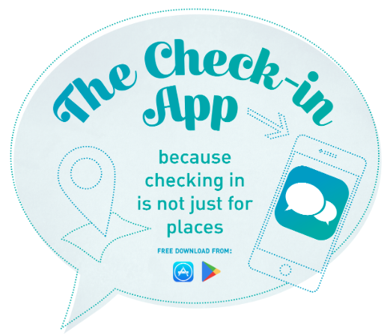 | The Check-In App  Helps young people to help take the fear out of having a conversation with a friend who might be struggling. The app takes you through four steps, super easy and super quick, getting you to think about where you might check in, what you might say and how might you support your friend.
MindSpot Mood Mechanic
‘Mood Mechanic Course’ – An online program for stress, worry, anxiety and depression in people aged 18-24. The course aims to help people to learn to break unhelpful habits and learn to overcome symptoms.

