STAR Program Application
to Loganlea SHS

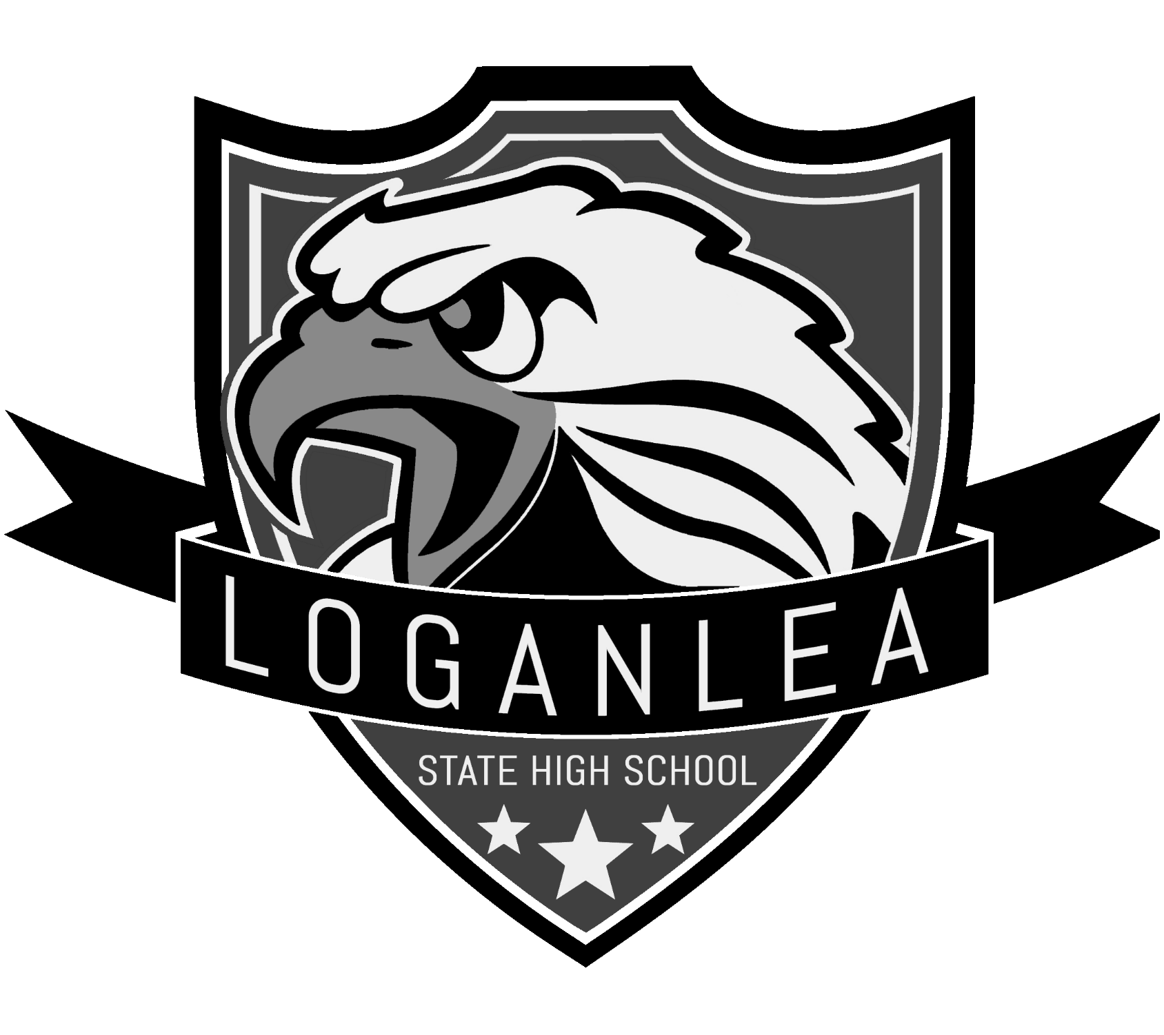
Application for Loganlea SHS STAR Program

Student Details:

Name

Current school

Current year level

Parent/Carer Contact Details:

Name

Postal Address

Street address Postcode

Contact

Mobile Email

Signature :

Date

Please indicate which STAR program scholarship(s) you are applying for:

Loganlea Institute of Sport (Years 7,8,9, 10)

Loganlea Youth Development Program (LYDP)
Jnr LYDP (Year 7,8,9)

Agribusiness (Agriculture)

Loganlea Youth Development Program (LYDP)
Snr LYDP (Year 10,11,12)

Loganlea Institute of Sport
“UPPER 90” Football/Futsal Excellence 2021 (Year 7) (Year 8-12 Offline)

Signature (Academic/STEM)

Hospitality
Senior Dance
(Years 10,11,12)
Junior Dance
(Years 7,8,9)

Application: Outline why you believe you should be accepted into the relevant STAR program. Discuss your previous experience/expertise in the area, involvement in extra-curricular events
and/or competitions. Please attach evidence such as certificates of achievement, personal references and any extra pages required, overleaf.

General Student Information

Favourite Subjects:

School or Community Leadership positions held:
(e.g. Student councillor, house captain, band captain, sports captain):

School or community activities or achievements:
(e.g. Eisteddfods, Opti-minds, Club or Representative teams, Community service):

By applying for a STAR program at Loganlea State High School, I agree to:
- Meeting expectations outlined in STAR Program Code of Conduct
- Maintain excellence in attendance
- Demonstrate the highest standards of behaviour and effort across the curriculum, and
- actively participate in skill development and associated extra-curricular events and competitions

Name

Student Signature

Date

Please return the completed form and any attachments (including the most recent report card) to the school via Email (STAR@loganleashs.eq.edu.au), Post (Neridah Street, Loganlea, 4131), or in person.
Report Card

NAPLAN results (Signature Program only)

Scholarships are available for outstanding applicants. I would like to apply for a scholarship
No
Yes

If applying for a scholarship please complete the Scholarship Application.
Please advise below, how you heard about Loganlea SHS and our STAR Programs.
Other
Newsletters
Facebook
Flyer

